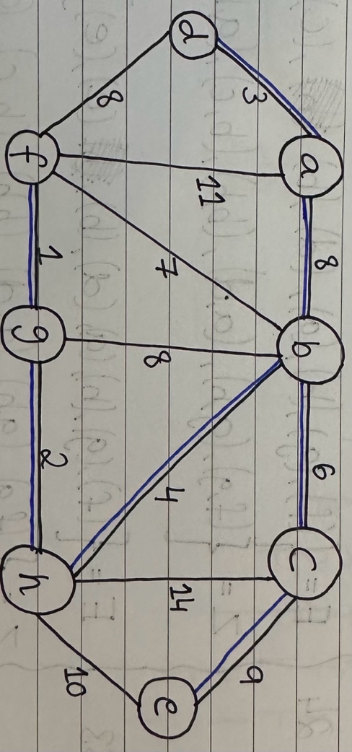Intro to Computer Science

Sheet#01

Submission by: Bilal Waraich

*Worked in Group: Giovanni Falconer, Zaur Alizada, Nikolay Lachezarov Tsonev*

**Problem 1.1:**

1. V = {a, b, c, d, e, f, g, h}

A = {(a, b), (a, d), (a, f), (b, f), (b, g), (b, h), (b, c), (c, h), (c, e), (e, h), (h, g), (g, f), (f, d)}

G= {V, A}

1. Step 0:

C = 0

Z = {(a), (b), (c), (d), (e), (f), (g), (h)}

E = {}

Step 1:

C = 1

Z = {(a), (b), (c), (d), (e), (f, g), (h)}

E = {(f, g)}

Step 2:

C = 3

Z = {(a), (b), (c), (d), (e), (f, g, h)}

E = {(f, g), (g, h)}

Step 3:

C = 6

Z = {(b), (c), (a, d), (e), (f, g, h)}

E = {(f, g), (g, h), (a, d)}

Step 4:

C = 10

Z = {(c), (a, d), (e), (b, f, g, h)}

E = {(f, g), (g, h), (a, d), (b, h)}

Step 5:

C = 16

Z = {(a, d), (e), (b, c, f, g, h)}

E = {(f, g), (g, h), (a, d), (b, h), (b, c)}

Step 6:

C = 24

Z = {(e), (a, b, c, d, f, g, h)}

E = {(f, g), (g, h), (a, d), (b, h), (b, c), (a, b)}

Step 7:

C = 33

Z = {(a, b, c, d, e, f, g, h)}

E = {(f, g), (g, h), (a, d), (b, h), (b, c), (a, b), (c, e)}

**Problem 1.2:**

a)

b)

c)

**Problem 1.3:**

1. Non-associative operators in Haskell without additional parenthesis to give an order of precedence will result in an incorrect calculation being computed. This can be visualised with the use of the ‘ˆ’ exponent operator. If a calculation were to be coded without parenthesis like the following:

3 ^ 2 ^ 3

Will produce the following answer: 6561.

However, the correct answer would be: 729 which is computed with the following format: (3^2)^3

Hence, the use of parenthesis is important for establishing precedence in Haskell for non-associative operators.

1. The $ operator in Haskell tells the compiler to compute the arithmetic operations on the right side of the $ sign giving it precedence. Hence, meaning that this operator is right-associative. This (^) 2 $ (*) 4 $ (+) 13 operation can be writing in infix notation as the following:

(2 ^ (4 * (1 + 3)))